**Experiment No. 08**

* 1. **Experiment Name**

Simulation on hysteresis control of grid connected H-bridge system

* 1. **Objectives**
* To get familiarize with the Simulink platform and Simulink library
* To develop and study a H bridge inverter using Simulink
* To use the Simulink platform to construct and analyze a hysteresis control of H bridge inverter
  1. **Theory**

**Hysteresis control of grid connected H-bridge system**

The purpose of the current controller is to control the load current by forcing it to follow a reference one. It is achieved by the switching action of the inverter to keep the current within the hysteresis band. The main advantages of this nonlinear control technique are related to its simple implementation, performing time response, and robustness.

* 1. **Apparatus**
* Simulink
  1. **Simulink Block Diagram & Waveform**

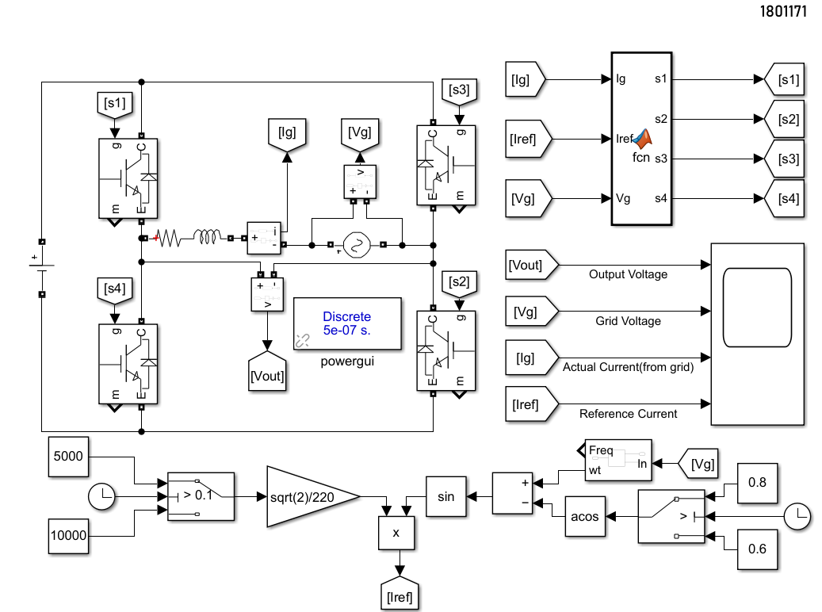

Fig.8.1: Block diagram of hysteresis control of grid connected H bridge system

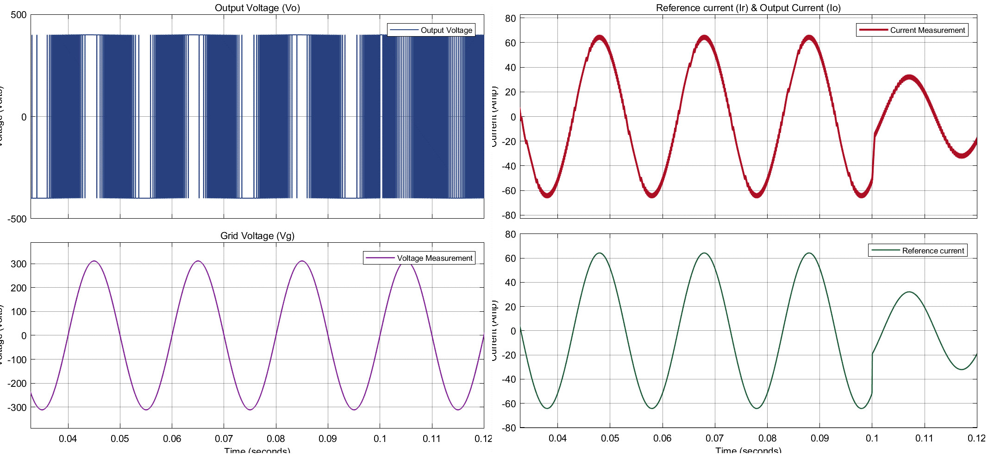

Fig.8.2: Waveform of bipolar hysteresis control of grid connected H bridge system

**MATLAB Code**

function [s1,s2,S3,S4] = fcn(Vg,Ig,Iref)

persistent Q1; if isempty(Q1) Q1=0; end

persistent Q2; if isempty(Q2) Q2=0; end

persistent Q3; if isempty(Q3) Q3=0; end

persistent Q4; if isempty(Q4) Q4=0; end

delta=1;

e=Ig-Iref;

if Vg>=0

if e<=-delta

Q1=1; Q2=1; Q3=0; Q4=0;

elseif e>=delta

Q1=1; Q2=0; Q3=1; Q4=0;

else

Q1=Q1; Q2=Q2; Q3=Q3; Q4=Q4;

end

else

if e<=-delta

Q1=1; Q2=0; Q3=1; Q4=0;

elseif e>=delta

Q1=0; Q2=0; Q3=1; Q4=1;

else

Q1=Q1; Q2=Q2; Q3=Q3; Q4=Q4;

end

end

s1=Q1; s2=Q2; S3=Q3; S4=Q4;

end

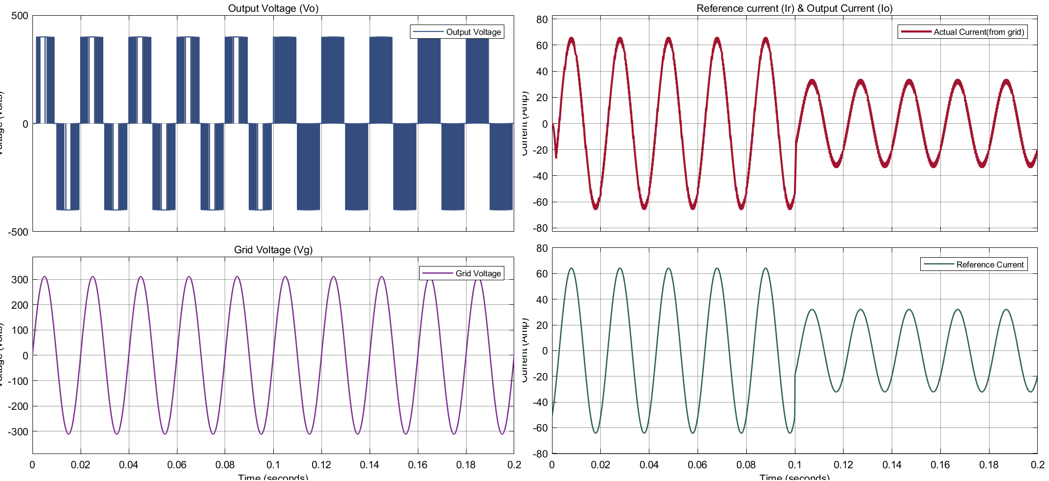

Fig.8.2: Waveform of unipolar hysteresis control of grid connected H bridge system

**MATLAB Code**

function [s1,s2,s3,s4] = fcn(Ig,Iref,Vg)

persistent Q1

if isempty(Q1);Q1=1;end

persistent Q2

if isempty(Q2);Q2=1;end

persistent Q3

if isempty(Q3);Q3=0;end

persistent Q4

if isempty(Q4);Q4=0;end

hd=2;

e=Ig-Iref;

if Vg>=0

if e<=-hd

Q1=1;Q2=1;Q3=0;Q4=0;

elseif e>=hd

Q1=1;Q2=0;Q3=1;Q4=0;

else

Q1 = Q1;Q2=Q2;Q3=Q3;Q4=Q4;

end

else

if e<=-hd

Q1=0;Q2=1;Q3=0;Q4=1;

elseif e>=hd

Q1=0;Q2=0;Q3=1;Q4=1;

else

Q1 = Q1;Q2=Q2;Q3=Q3;Q4=Q4;

end

end

s1=Q1; s2=Q2; s3=Q3; s4=Q4;

end

* 1. **Discussion & Conclusion**

This experiment thoroughly investigated hysteresis control of grid connected H bridge system. For this system, we utilized connection and value of parameter according to our preference. Similarly, for Hysteresis control inverter, we used necessary tool according to our requirements. Thus, desired output was observed and the simulation was a success.